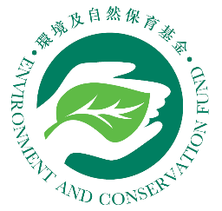 | Environment and Conservation Fund  Educational Education and Community Action Projects  (EE&CA)  Survey on Participants  (To be filled out by participants)
The purpose of this survey is to assess the effectiveness of the activity for reference to future review and enhancement. Please “” the appropriate box that best describes your comment. Thank you.
Name of Project and activity : ______________________________ Date of activity : ______________
(suggested to be filled out by recipient organization on behalf of participants)

 |  |  | Strongly agree | Agree | Neutral | Disagree | Strongly disagree
 | The activity has enhanced participants’ environmental knowledge and understanding of environmental problems in Hong Kong
 | The activity has enhanced participants’ environmental awareness
 | The activity has aroused participants’ interest in joining other environmental activities
 | The activity helps participants’ to put environmental knowledge into practice in daily life (e.g. waste reduction / separation and recovery of waste / energy saving / conservation of water resources)
 | The activity helps participants to spread environmental messages to their families, schoolmates and friends
Other comments / suggestions
(Please use supplementary sheets if the space provided is insufficient)
Other comments on improving the EE&CA activities
(Please use supplementary sheets if the space provided is insufficient)
~Thank you for your valuable comments~

